Data Pipeline and ETL

Data Pipeline:

A data pipeline is a series of processes and tools that automate the movement and transformation of data from one system to another. It's commonly used in data engineering, analytics, and machine learning to ensure data flows smoothly from its source to its destination—like a database, data warehouse, or dashboard.
Here's a simple breakdown:
1. Data Sources
These are where the data originates. Examples include:
- Databases (e.g., MySQL, PostgreSQL)
- APIs
- Files (CSV, Excel)
- Sensors or logs
2. Ingestion
This step pulls data from the source. It can be:
- Batch ingestion (e.g., once a day)
- Streaming ingestion (e.g., real-time data from IoT devices)
3. Processing/Transformation
Raw data is cleaned, formatted, and transformed. This might include:
- Removing duplicates
- Converting formats
- Aggregating or filtering data
4. Storage
Processed data is stored in a destination like:
- Data warehouses (e.g., Snowflake, BigQuery)
- Data lakes
- Relational databases
5. Analysis/Consumption
The final data is used for:
- Business intelligence dashboards
- Machine learning models
- Reports and decision-making
Example:
Imagine an e-commerce company:
- Data from website clicks, purchases, and customer profiles is collected.
- A pipeline ingests this data daily.
- It cleans and combines the data.
- Stores it in a data warehouse.
- Analysts use it to generate sales reports and customer insights.

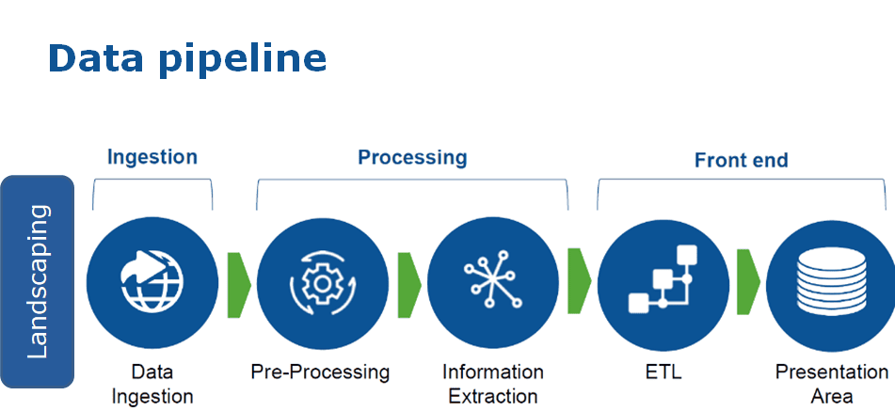

ETL:

ETL stands for Extract, Transform, Load. It’s a key process in data engineering used to move and prepare data for analysis or storage. Here's what each step means:

Extract
This is the first step where data is pulled from various sources, such as:
- Databases (e.g., Oracle, MySQL)
- APIs
- Files (CSV, Excel)
- Cloud services
The goal is to gather raw data from wherever it lives.

Transform
Once data is extracted, it often needs to be cleaned and reshaped. This step includes:
- Removing duplicates or errors
- Changing formats (e.g., date formats)
- Combining data from multiple sources
- Applying business rules (e.g., calculating totals or averages)
This makes the data usable and consistent.

Load
Finally, the transformed data is loaded into a destination system, such as:
- A data warehouse (e.g., Snowflake, Redshift)
- A database
- A data lake
This is where the data is stored for analysis, reporting, or machine learning.
Example:
Imagine a retail company:
- Extract: Pulls sales data from store databases.
- Transform: Cleans the data, calculates daily totals, and converts currencies.
- Load: Stores the final data in a central warehouse for dashboards and reports.

